**Simple Weather MCP Server**

Node.js server implementing [Model Context Protocol (MCP)](https://modelcontextprotocol.io/) for accessing weather information in the US.

Source: <https://github.com/hideya/mcp-server-weather-js>

Install Claude Desktop and do the below highlighted changes in claude_desktop_config.json present in the below location -

Goto Claude Desktop >File > Settings >Developer > Edit Config

"C:\Users\ekris\AppData\Roaming\Claude\claude_desktop_config.json"

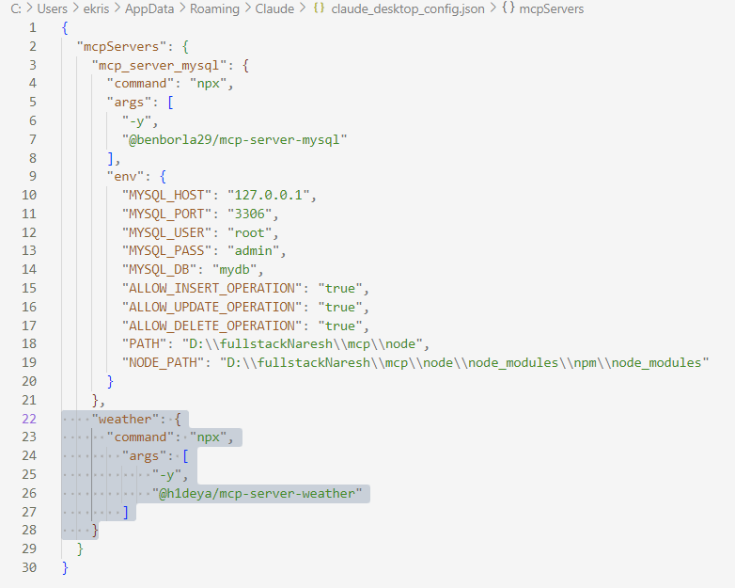

Restart the Claude desktop > File > settings > Developer and make sure the Weather mcp is running

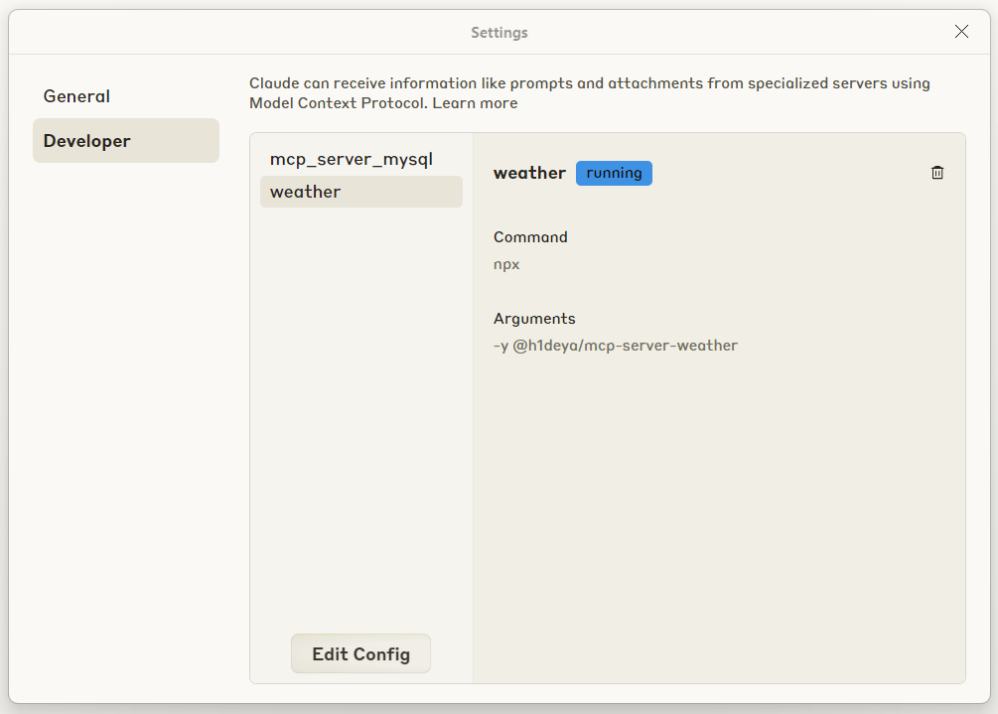

Goto to Claude desktop and check for tools related to weather

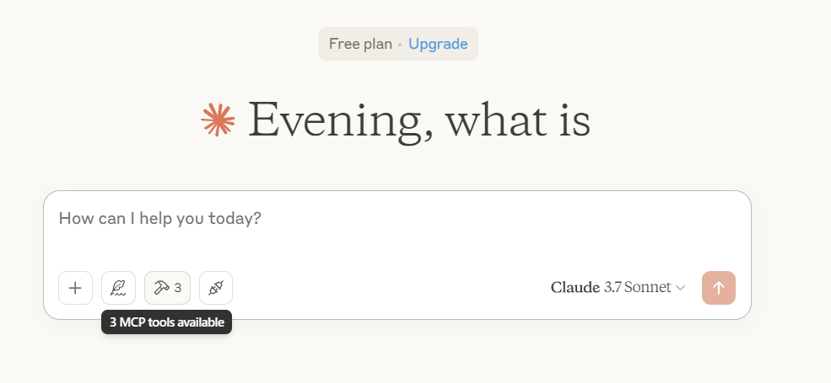

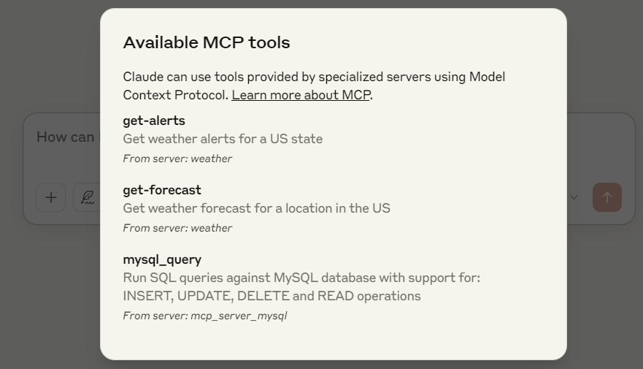

Two MCP tools related to weather are available –

**1.get-alerts**

* + **Get weather alerts for a US state.**
  + **Input: state (string): Two-letter US state code (e.g. CA, NY)**

**2.get-forecast**

* + **Get weather forecast for a location in the US**
  + **Inputs:**
    - **latitude (number): Latitude of the location**
    - **longitude (number): Longitude of the location**

**Input/Output:**

